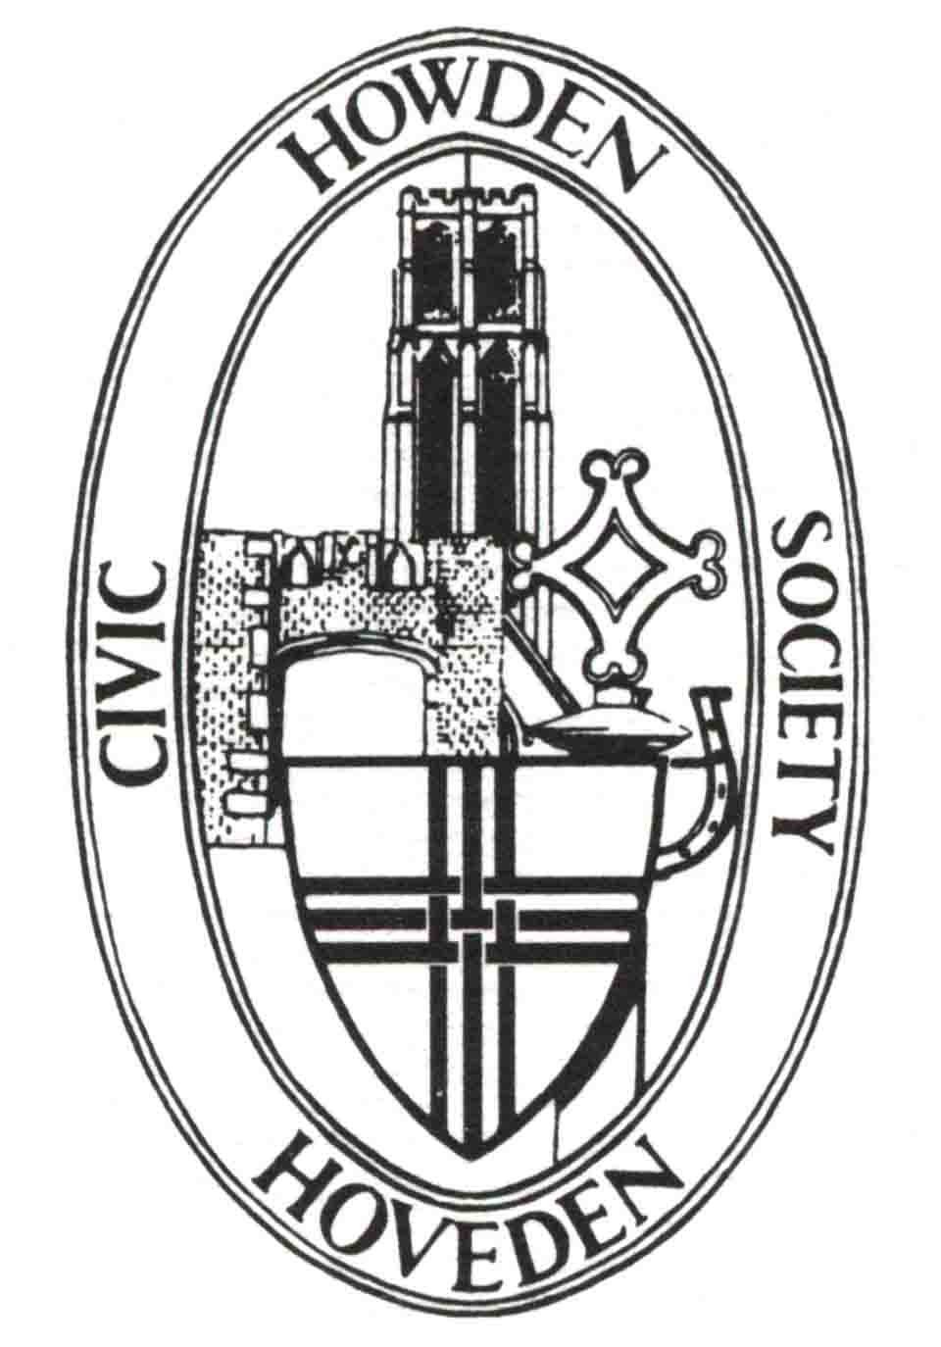
Howden Civic Society

May Newsletter

Letter from the Chairman
We are currently working to raise funds to replace the headstone of Charles Ledsham in Howden Minster churchyard. He was one of the very few survivors of the Battle of Waterloo who can be identified by his grave but who was not an officer. You can help us raise the necessary funds without actually costing you anything. This is by supporting us for free on #easyfundraising. Your ongoing support means the world to us! If you've not signed up yet, please join today and you can raise free donations for Howden Civic Society every time you shop online this year! Over 8,000 retailers like eBay, Argos, Marks and Spencer, John Lewis & Partners, Etsy, Tesco and Just Eat will donate at no extra cost to you. Log into www.easyfundraising.co.uk and select Howden Civic Society as your favoured cause to support.
Easyfundraising partners with over 8,000 brands who will donate part of what you spend to a cause of your choice. It won't cost you any extra. The cost is covered by the brand.
The work can start as soon as we raise enough funds so please help us without the need to incur any cost to yourselves. “Every little helps” as they say.
Dates for your diary

We look forward to our visit to Ellerton Priory on Wednesday 4th June at 2.0 pm when we will be guided through the discovery and restoration of the Priory church of St Mary and St Lawrence at Ellerton, usually known more simply now as Ellerton Church. It stands at the far end of Ellerton village in the East Riding of Yorkshire overlooking the vast airy spaces of the Derwent Ings – internationally important flood meadows.
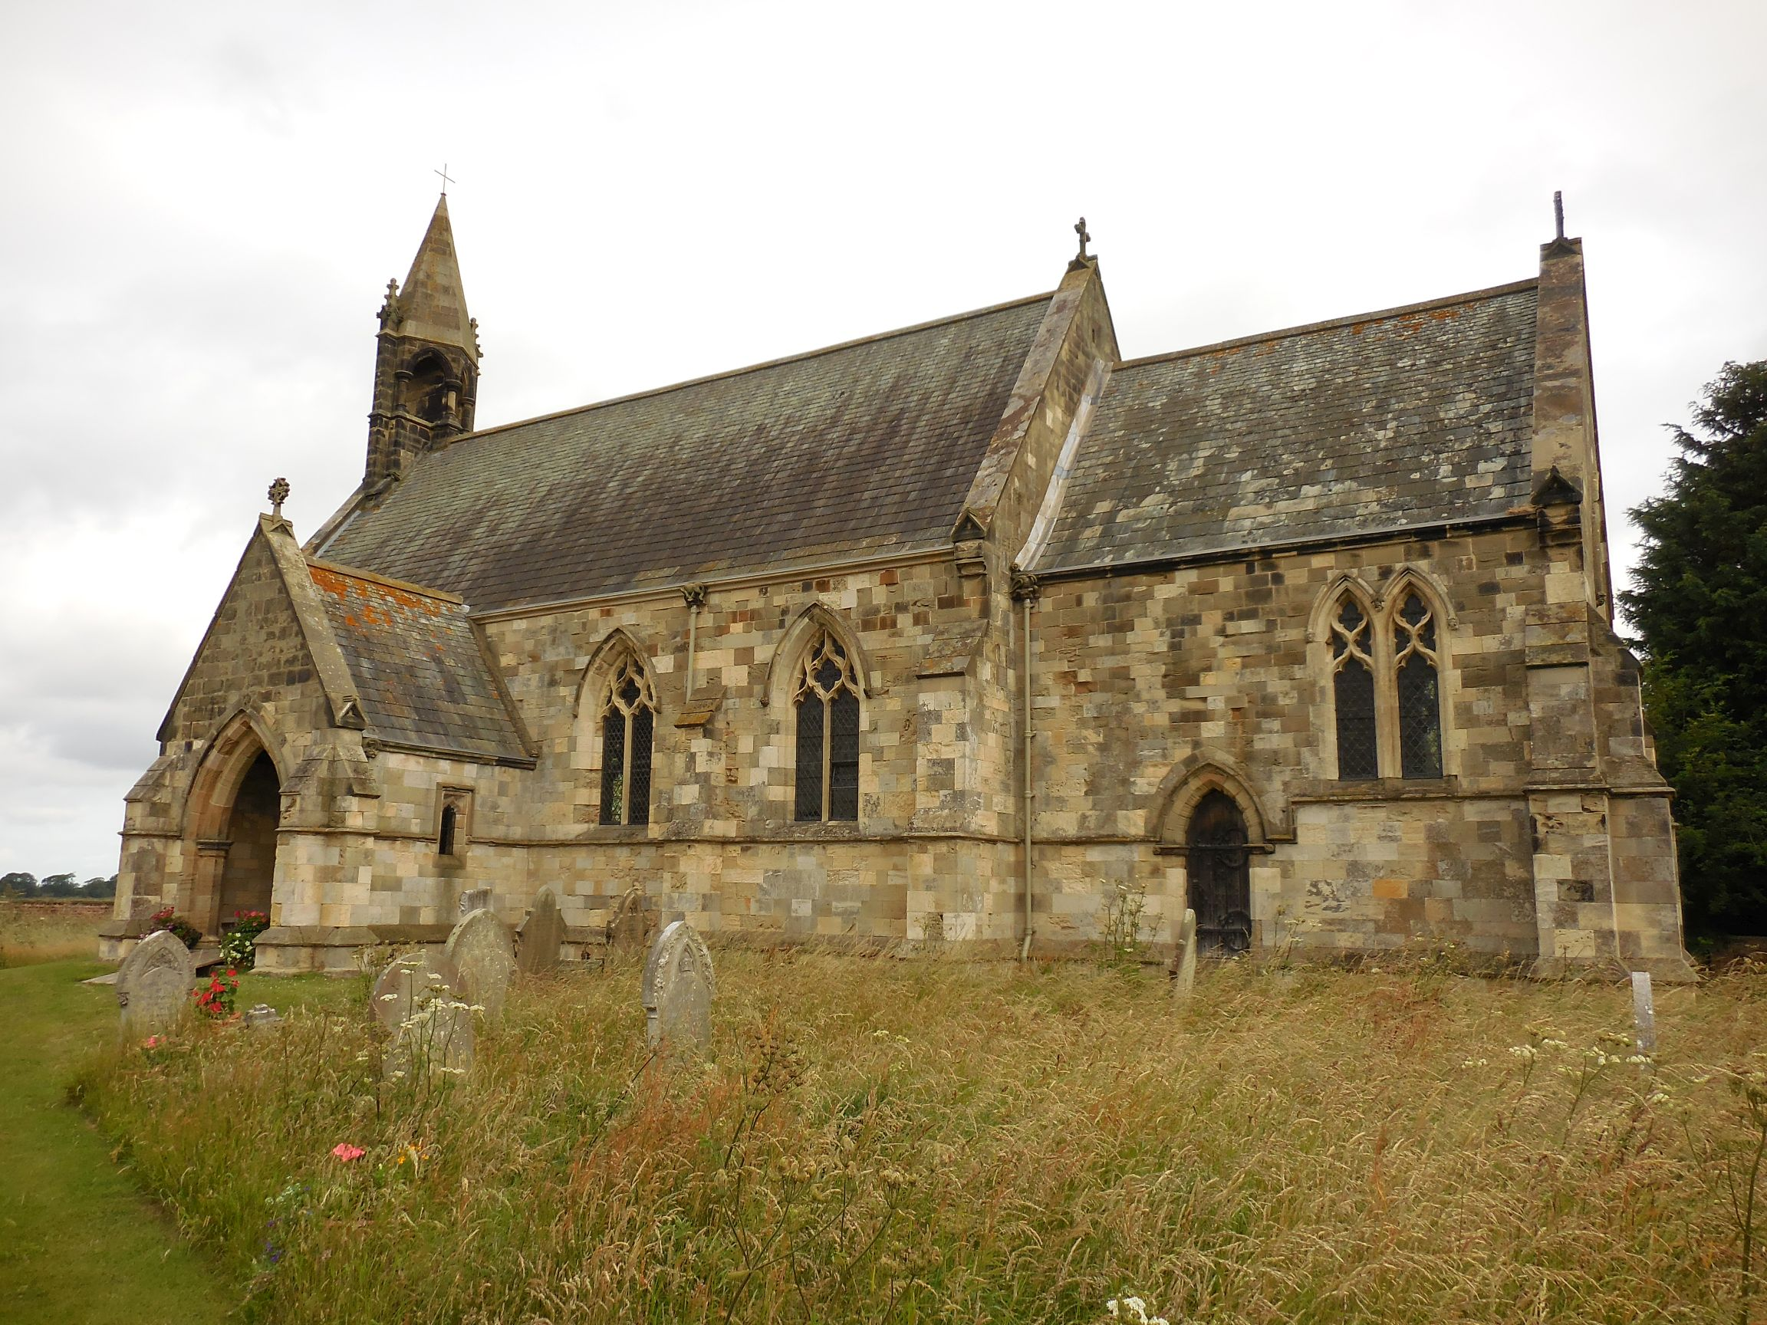

You will be able to see and hear about the complex and fascinating history of Ellerton Priory Church, its rescue and restoration by the Ellerton Church Preservation Trust, and the landscape of the Lower Derwent Valley.

The visit will be hosted by Phil Thomas whose experience and enthusiasm will be conveyed to all who attend. Attendance is free but the Trust would welcome donations and purchases to enable the ongoing restoration work to continue. Delicious cakes will also be available produced by Michael Thomas. There is no need to book but please arrive in good time for the visit. There should be car parking available in the adjacent field.

And finally plans are already underway to hold an exhibition in the Shire Hall during Heritage Open Days. We have had to change the day of opening to Sunday 21st September so please make a note of the change in your diaries.
Report of recent meeting
Although our speaker Henry Farrar was unable to attend on 7th May, we were able to show his presentation of “Rides through Yorkshire with Daniel Defoe”.
This proved to be a fascinating exploration of Yorkshire during the early 18th century when travelling must have been very difficult and time consuming. Defoe’s insight into the county at that time was an eye-opener. Although Howden wasn’t mentioned in the presentation, I have copied some of his comments from a letter he wrote at that time:
“There are some few market towns in these low parts between this place [Isle of Axholme] and the Humber, though none of great consideration, such as Thorne upon the Don, Snathe upon the Aire, Selby upon the Ouse, and Howdon near the same river; the two last are towns of good trade, the first being seated where the Ouse is navigable for large vessels, has a good share in the shipping of the river, and some merchants live and thrive here; the latter is one of the towns in England, where their annual fairs preserve the name of a mart, the other Lyn, Boston, Ganesborough, Beverley, tho’ of late they begin to lose the word. The fair or mart held here is very considerable for inland trade, and several wholesale tradesman come to it from London. But I take this town to be more famous for the birth of one of our antient historians, (viz.) Roger of Hovedon or Howdon; Mr. Cambden’s continuator is much in the wrong to say this town stands upon the Derwent; whereas it is above three mile east of the Derwent, and no river of any note near it but the Humber.”

Committee News
Our meeting on 9th May included the following progress:
We still need £2,200 to be able to ask the stonemason to start production of the headstone for Charles Ledsham. Although this is a considerable sum of money, it would be one of only a handful of memorials to Waterloo heroes, who were not officers, in the whole country and would be a notable addition to Howden’s heritage.

Vintage day exhibition in the Minster proved to be a great success with the display of old photos on the TV being a great attraction. We’ll try to repeat this for the Heritage Open Day exhibition.

Thanks to Lin Lavender and Marian Thomas for judging the Traders Vintage Window Displays and the successful traders – Dove House (1st), Bishops Bar (2nd) and Dixies Dog Spa (3rd) were recipients of certificates from the organisers Howden Town Council.
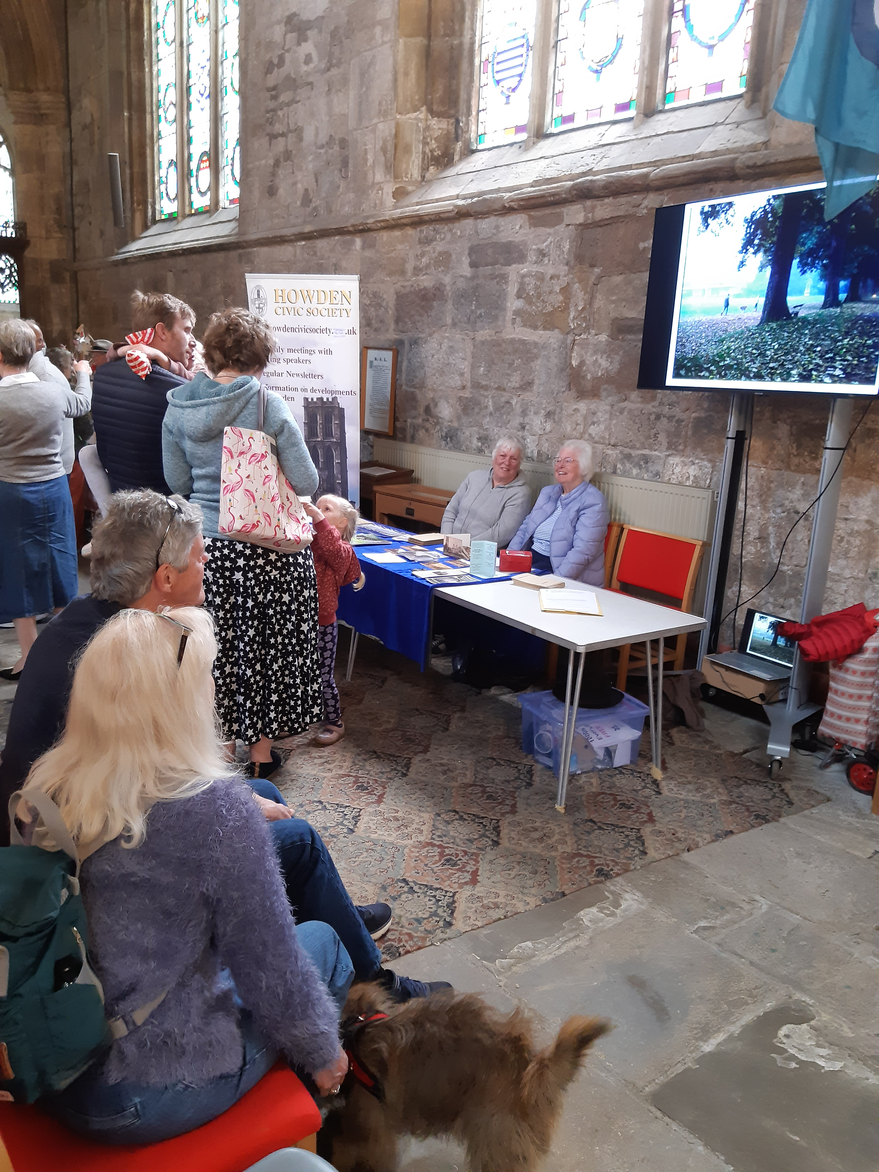

We decided not to subscribe to Civic Voice, the campaign leaders for Civic Societies across the country, because we are members of the Yorkshire and Humberside Association of Civic Societies and they can provide us with admirable advice and support.

Our activities in preparing the 2026 social meeting programme is progressing. We still have a couple of gaps but the details of the programme should be available by the time of the Howden Show in July when we should be having a table in the Trade tent as we did last year.

During the Heritage Open Days in September we plan to exhibit about the R100 and use the opportunity to gather more information about people who worked on the airfield site. Any anecdotes would be gratefully received.

We will be contacting members to request that their gift aid declarations are up to date to ensure we comply with HMRC expectations.

Howden’s Heritage
Although not completely within the boundaries of Howden or Howdenshire, the news that the huge solar farm north of Howden has been given governmental consent was received recently.
This has been identified as a nationally significant infrastructure project by the government and they therefore provided the development consent order on 9th May. The following information has been taken from an article in Goole Times of 15th May.
“The solar power plant will be sited between the hamlet of Gribthorpe, the villages of Spaldington and Wressle and the town of Howden and cover a total area of 1,445 hectares. Buffer zones and screening vegetation will reduce visual impact, while existing hedgerows will be preserved. The development includes the creation of wildlife habitats, such as grassland and woodland zones, and a large area adjacent to the River Foulness has been included within the outer limits to support overwintering bird species. The project will also preserve public rights of way and introduce permissive paths.”
There is also a path identified to connect this solar farm with the National Grid at the Drax substation. This leads from near Spaldington diagonally south-westwards across the railway west of Brind, past Brackenholme, alongside and across the Derwent river to Long Drax.
The developer, Boom Power, expects that construction will take three years.
The project involved includes large areas just north of the railway at North Howden and south and west of Brind including on the Howden side of the railway almost as far as Newsholme.

Then and Now
(Taken from the newsletter of September 2009)

RHUBARB RHUBARB RHUBARB
Members recently went on a visit to the Wakefield Rhubarb Triangle which is an unusual horticultural phenomenon. For those
of you who missed the trip the fascinating history of rhubarb might be of interest.
Wakefield is part of the Wakefield-Leeds-Morley rhubarb-growing triangle and the plant has been an important part of the local economy for over 150 years.
Originally grown for local markets it wasn’t long before special rhubarb trains were leaving Wakefield [and East Ardsley] for London every day laden will tons of rhubarb.
Although this heyday may be long past, rhubarb growing is still flourishing and the introduction of an annual Rhubarb Festival marks the importance of it to Wakefield.

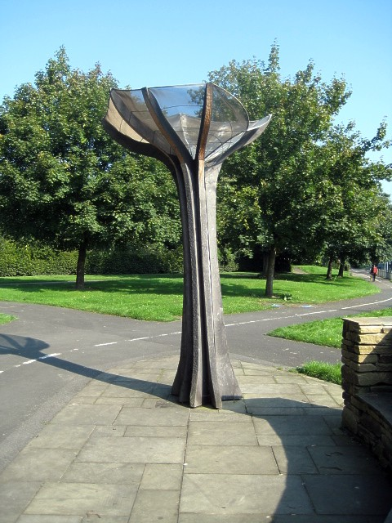

Rhubarb sculpture in Wakefield

Rhubarb originates from the Russia/China border area. It has been used since ancient times for medicinal purposes, usually in a dried form as a laxative. It was first grown in this country in the 1760s for scientific purposes at Edinburgh’s Botanical Gardens.

It is unknown when the plant began to be cultivated in the Wakefield area. It gradually began to appear, firstly, as an ornamental garden plant although some may have been grown for medicinal reasons or to eat. However, by the 1840s local market gardeners were growing rhubarb as a fruit for stewing and to use in pies and jams.

The idea of ‘forcing’ rhubarb - growing it indoors under dark and warm conditions - was probably ‘discovered’ in the 1820s but it was not taken up by market gardeners on a large scale until the 1880s.
The long low ‘forcing’ sheds are a unique, and now a rapidly disappearing, part of the local landscape.
The rhubarb sheds are an eerie place by candlelight and, if you are very quiet, you can actually hear the plants growing…
Rhubarb flourished in this part of the country because it seems to have had the ideal combination of conditions necessary to cultivate rhubarb on a large scale. These included:-
- suitable soil
- sufficient rainfall
- supplies of soot and ash to condition the soil
- cheap fuel to heat the sheds
- large numbers of small market gardeners

Little is known in detail about the development of the rhubarb industry in the area because there were no big growers only small market
gardeners and few records were kept.
If you would like to know more about the local industry you are recommended to read the article, ’The Story of Rhubarb’ written by
local historian John Goodchild included in the book Aspects of Wakefield (Wharncliffe Publishing 1998).

Alan Dalton originates from Outwood in the West Riding of Yorkshire, the heart of the rhubarb triangle. He started gowing rhubarb in 1935. His grandson Johnathan Hick carries on this tradition in Park Farm in Howden growing the same roots and varieties his grandfather did in the same tried and tested way producing Yorkshire's finest delicacy, indoor rhubarb!

P.S. Your current chairman lived in the rhubarb triangle before moving to Howden some years ago.

Planning Matters
The most significant development that I have identified in this area recently is the Boom Power solar farm development north of Howden.

The Minster View has now obtained approval of its development plans and there seems now to be no legislative reason why its refurbishment cannot now commence.
Th
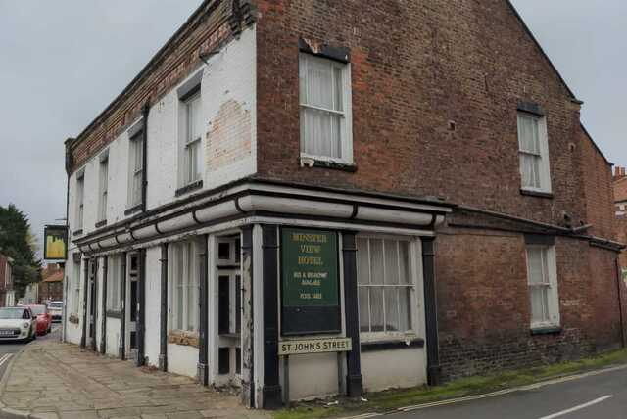

Picture source: Hania Franek

In conclusion
Our contact details are as usual:

email: info@howdencivicsociety.co.uk

mail to: Howden Civic Society
c/o The Shire Hall
Market Place
Howden
East Riding of Yorkshire
DN14 7BJ

Philip Mepham,
Chairman, Howden Civic Society
24th May 2025

