
Howden Civic Society

March 2025 Newsletter

1. Letter from the Chairman
The AGM outcome is reported later. I would like to offer sincere thanks to our Committee for their support and advice during the past year which has made my job considerably easier. We have a busy year during 2025 but we could always do with more help. Our committee is small but never short of ideas. Our only constraint is the number of people who can help. You know whee to find us.

2. Dates for your diary
Our next social meeting will be on Wednesday 2nd April in the Masonic Hall starting at 7.30 pm when we shall hear and see what another of our local businesses are doing. Martin Ellis’s presentation will be all about PLANT RAISERS and I am sure we will learn a great deal about how their company operates.

Other dates for your diary include our stand in the Minster on Howden’s Vintage Day on Saturday 3rd May. We plan to present a reel of vintage photos showing Howden in the 1930s and 1940s.

Following that, Howden Show is on Sunday 6th July when we hope to have a stand in the trade Tent like last year.

Then Heritage Open Days are held between 12th - 21st September. We are still working on what we can arrange so keep a look out for more details as they emerge.

There may be more but no dates have been arranged yet.

These three events are in addition to the monthly social meetings which are listed on your Calendar of Events. If you don’t have a copy of the blue leaflet, let me know and one will be delivered to you.

3. Report of recent meeting
We have had two meetings since my last newsletter.
On 5th February we were fascinated to hear about Angela Martinson’s early life and experiences in and around Howden. The meeting was very well attended, with many non-members.

Our AGM on 5th March was also well attended, but I suspect most had come to hear Philip Parkin and not to consider the paperwork relating to the AGM.
However, the following officers of the Society were elected for 2025/2026:
Chairman – Philip Mepham
Vice Chair – vacant
Secretary – Susan Butler
Treasurer – Arthur Henrickson
Committee members – Geoff Taylor
Diane Smith
Marian Thomas
Trudy Pankhurst-Green

The Chairman’s report was circulated as part of the January newsletter, but if you have lost it, and you are desperate to read it, I will endeavour to place it on our website.

Philip Parkin was joined by his father Roy who performed a double act reminiscing about the businesses around Howden’s centre in years gone by as well as some tales from the butcher’s block.

4. New on our website
As above, I plan to put the AGM reports on the website.

5. Committee News
We have had two Committee meetings since our last newsletter. The following are briefly the matters that were discussed:

12th February
We had obtained approval from the Chancellor of the Dioceses and Official Principal of the Lord Archbishop of York to remove Charles Ledsham’s headstone and replace it with a new one. Fundraising can now start in earnest.
We have a stock of slides made available by Howden Camera Society and will now review them and store them digitally.

We have compiled a preliminary list of improvements to pavements around Howden which will make them more accessible for people with mobility scooters or wheelchairs. These will be referred to ERYC Highways.

We were pleased to report that we have had a number of new members joining. We will carry out judging of Vintage Window Displays in conjunction with Howden Town Council.

We have clarified the roles and responsibilities for Committee members so all the jobs get done.
We have started to prepare the social meetings for 2026.

12th March
A fundraising site has been established for the new headstone. This will be reported in a forthcoming newsletter.
We will take part in a Study Day with part of York University by organising and escorting a walk/tour through Howden on 18th July.
We continued preparations for Vintage Day and Heritage Open Days.
Our membership numbers are stable compared with last year.

6. Howden’s Heritage
It is nice to see that our Grade 2 listed telephone box in St Helens Square has been repaired and all the broken panes of glass replaced in the door. I don’t know who commissioned this maintenance but we are very grateful.

The Telephone kiosk was listed in July 1988. The following description is taken from the British Listed Buildings site.

‘It is a Type K6. Designed 1935 by Sir Giles Gilbert Scott. Made by various contractors. Cast iron. Square kiosk with domed roof. Unperforated crowns to top panels and margin glazing to windows and door.’

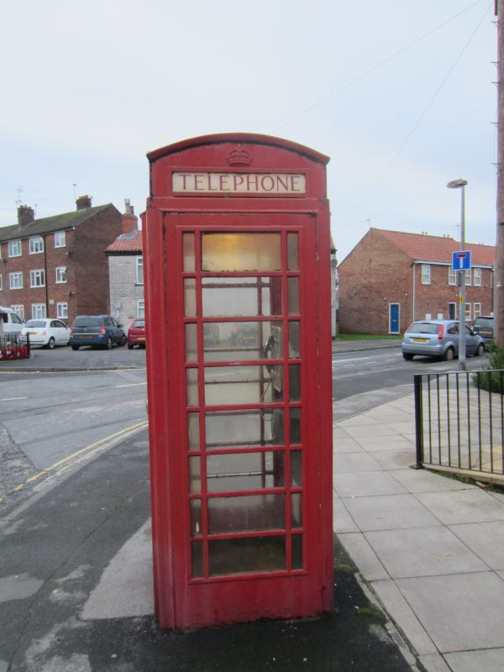

7. Then and Now
THE FILLING OF BUTLER’S GAP
Roger Watkins described the development, where the Howden Mural was sited, in the Newsletter of September 2007.

‘Two remarkable pieces of building work, of very different kinds, have been uncovered this summer in Howden. The scaffolding and the tarpaulins covering the west front of the Minster have been taken down, revealing the glorious refurbishment which the stone –masons and craftsmen have completed. And this has been completed in good time and under-budget! The creamy Tadcaster stone, both the original and the repaired, seems positively to gleam in the sun and English Heritage who footed the bill have good reason to feel delighted with the result.

But I want to discuss an altogether more modest undertaking, which in a sense concerns the Civic Society more directly. We were sent a copy of the original planning application for it, which after much discussion and with some reservations we eventually approved. Now that the protective fences have been taken down and the pavement and adjacent car parking spaces have been returned to their use, it is time to judge the building which has been constructed in the Marketplace filling what for many years was known as “Butler’s Gap”.
The gap was once the site of two shops but in recent years it was most effectively filled by the
mural displaying Howden’s history and by a bench which was the meeting place for some of the senior members of the town. Next door was Butler’s shop combining, unusually but very
conveniently, a newsagents’ and greengrocery business. When the Butlers decided to retire their shop and the land next door were sold. The Yorkshire Trading Company decided to demolish the old shop and build two retail units where there were once three. The Yorkshire Trading Co is based in Driffield where they build and operate shops for their own use as well as develop appropriate sites in other market towns as they have done in Howden.

They selected as their architect MJ Design of North Dalton near Driffield where Mike Jones is
the principal. He particularly enjoys the challenge of undertaking sympathetic conversions in rural areas, for example of old barns and seems to carry over to his more commercial work a respect for the setting in which a new building is to be constructed and the careful selection of materials appropriate to the age and style of the surrounding buildings. So in this case upvc windows were rejected and local suppliers were researched until a small firm in Hull was located, which was able
to manufacture and supply working-sash windows to exact specification. Bricks, tiles and slates in conformity with the existing street scene were sourced as locally as possible.

But a particular problem faced the architect and the builder (PDR Construction of Hessle). The
sub-soil of Howden town centre and most of its environs is, as Mr Jones put it, “poor quality silt”.
Piles have to be driven into the ground before the foundations can be safely laid. However there is an understandable resistance to the use of piling particularly in sensitive areas like the
Marketplace, close to the Minster and the many historically important buildings nearby.

Moreover piling is traditionally done from large caterpillar-tyred vehicles which hammer wide diameter piles into the ground. Leaving aside the horrendous nuisance such vehicles cause with vibration and noise, they simply could not be manoeuvred into that very restricted site.
Conscious of the complaints made when the Press Association building was constructed using traditional piling methods, M J Design went back to technical research again and came up with small diameter steel tubes of a shorter length (2.5 meters) which could be driven into the ground with less vibration and noise and then welded to another length as they went down until they reached the requisite depth of 17 or 18 meters. Using this method was of course expensive in time and money but considered by the construction team eminently worthwhile.

The exterior appearance of the building presented Mr Jones with another challenge. The gap was being filled with one unit but he wanted to avoid the appearance of a block being dropped in. So with variations of the roof height and use of both tiles and slates he manages to avoid uniformity and to remind us that three separate shops once stood here.
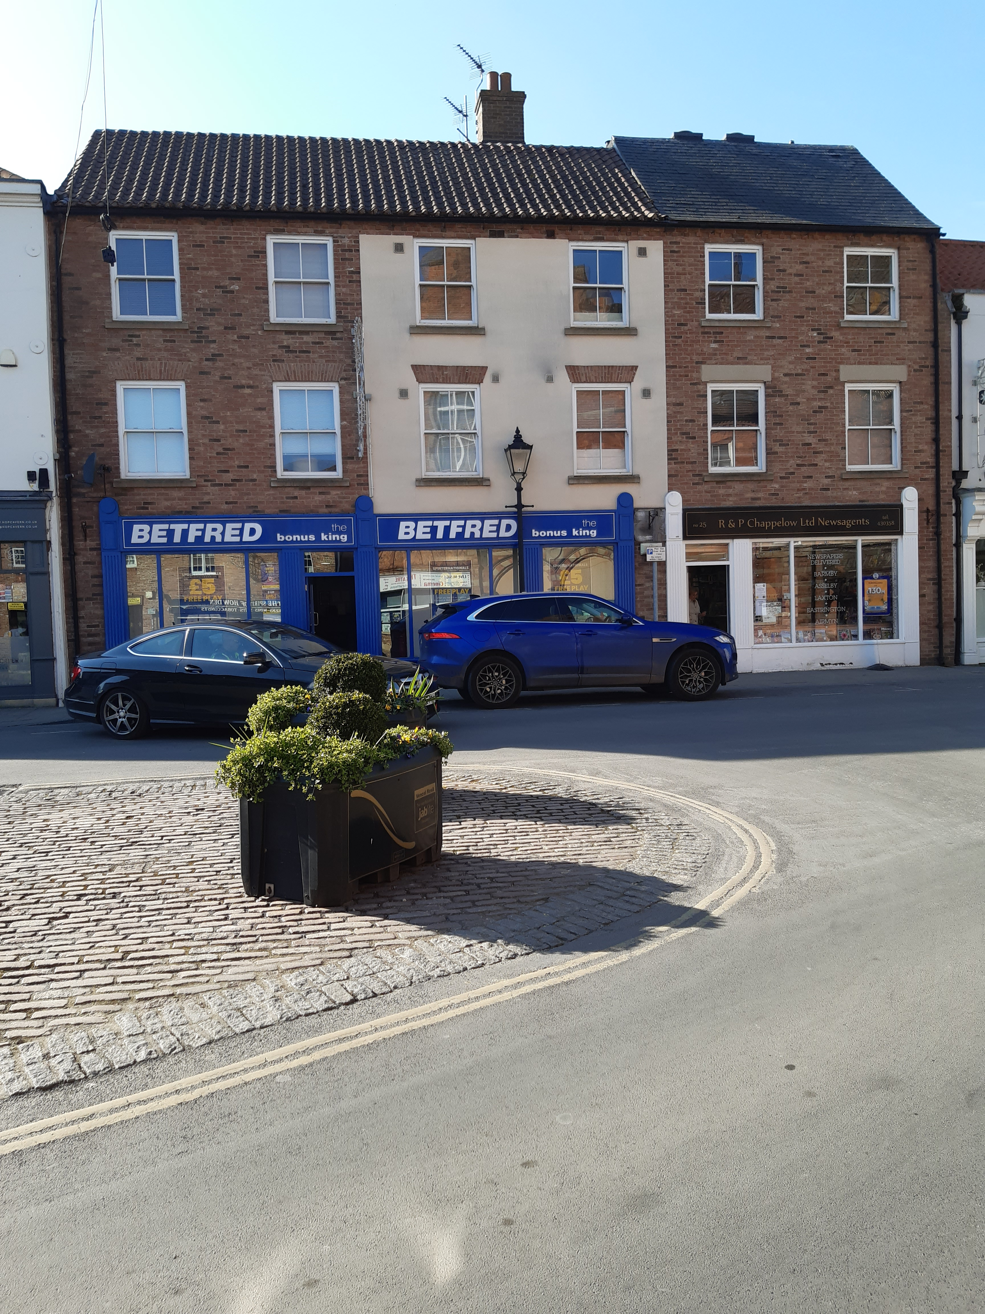
Butlers gap now

The final result is pleasing. Howden benefits
from the addition of two modern retail units
and seven apartments. There is only one snag
of course: lack of parking space. It was this
which worried the Civic Society committee
most when we first considered the planning
application. Where were the cars which would
inevitably be generated by the new residents
going to go? Unfortunately it seems that ERYC
(or the government) does not consider this is a
legitimate reason for objection to a planning
application. So Howden gains a fine new
building but loses even more of its ability to
cope with today’s traffic.

The Mural was photographed before it was removed and the Civic Society has reproduced the original mural from those photos and is displayed on suitable occasions. Below is a small part of the mural as an example of the whole, which showed the history of Howden from the time before William the Conqueror up until the Press Association building.

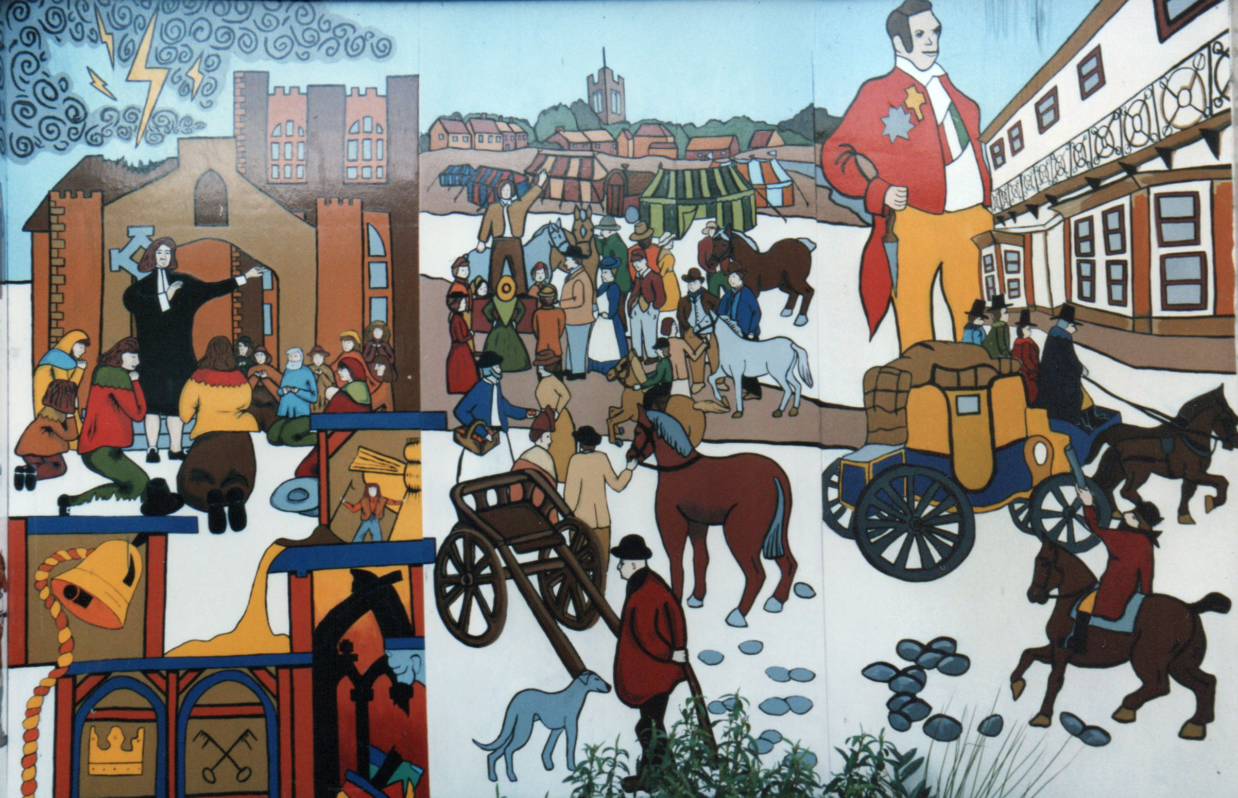
BACKGROUND TO THE HOWDEN TOWN MURAL

(All the text associated with these panels has been taken from an accompanying booklet published by the Town Forum)

‘The Howden Town Mural is one of the first projects to be developed by Howden Town Forum. This locally based organisation which had representatives from the public and private sectors and locally based community groups, was formed in April 1992 with the aim of encouraging the economic regeneration of the town.

With the permission of the landowner, Mr Michael Butler, and the National Westminster Bank, this previously disused site has been transformed to create a focal point of visual interest, highlighting the history of the town and surrounding area. The project has been designed so that the mural and the materials on the site can be used for other schemes when the site is permanently redeveloped.

The Town Mural has involved the local community and schools, and aspects of the various winning entries from an art competition sponsored by the Town Forum are represented in the finished work. Students from the Art and Design course at Hull College of Further Education’s Riley Centre have undertaken this project as part of their course work during 1993.

Howden Town Forum would like to pay special thanks to the students and staff of the college and also to the following individuals and organisations who have helped with this project.

Mr Barry Holliday, Builder; Mr Don Anson, Joiner; Mr Ken Powles; Mr Brian Leighton, Leighton Garage; Mr Peter Colbridge, Humberside County Council’s Architectural Salvage Officer and the pupils of Howden Junior School.’

8. Planning Matters
The ERYC Local Plan, including the Design Code, was approved by ERYC Cabinet on 25th February but as yet has not been approved by Full Council, as far as I can tell. Meanwhile work on the relief road between Station Road and Thorpe Road has started.

10. For Sale
Our publications, including the Guide to Howden’s Past – Howden’s Heritage, the Stroll around the Old Pubs of Howden, and the R100 Trail booklet are all available for sale at Chappelows, Touchwood and at our social meetings and exhibitions. We are very grateful for the help that those two retailers give the Society by making those publications available.

Philip Mepham
Chairman
Howden Civic Society
20th March 2025

