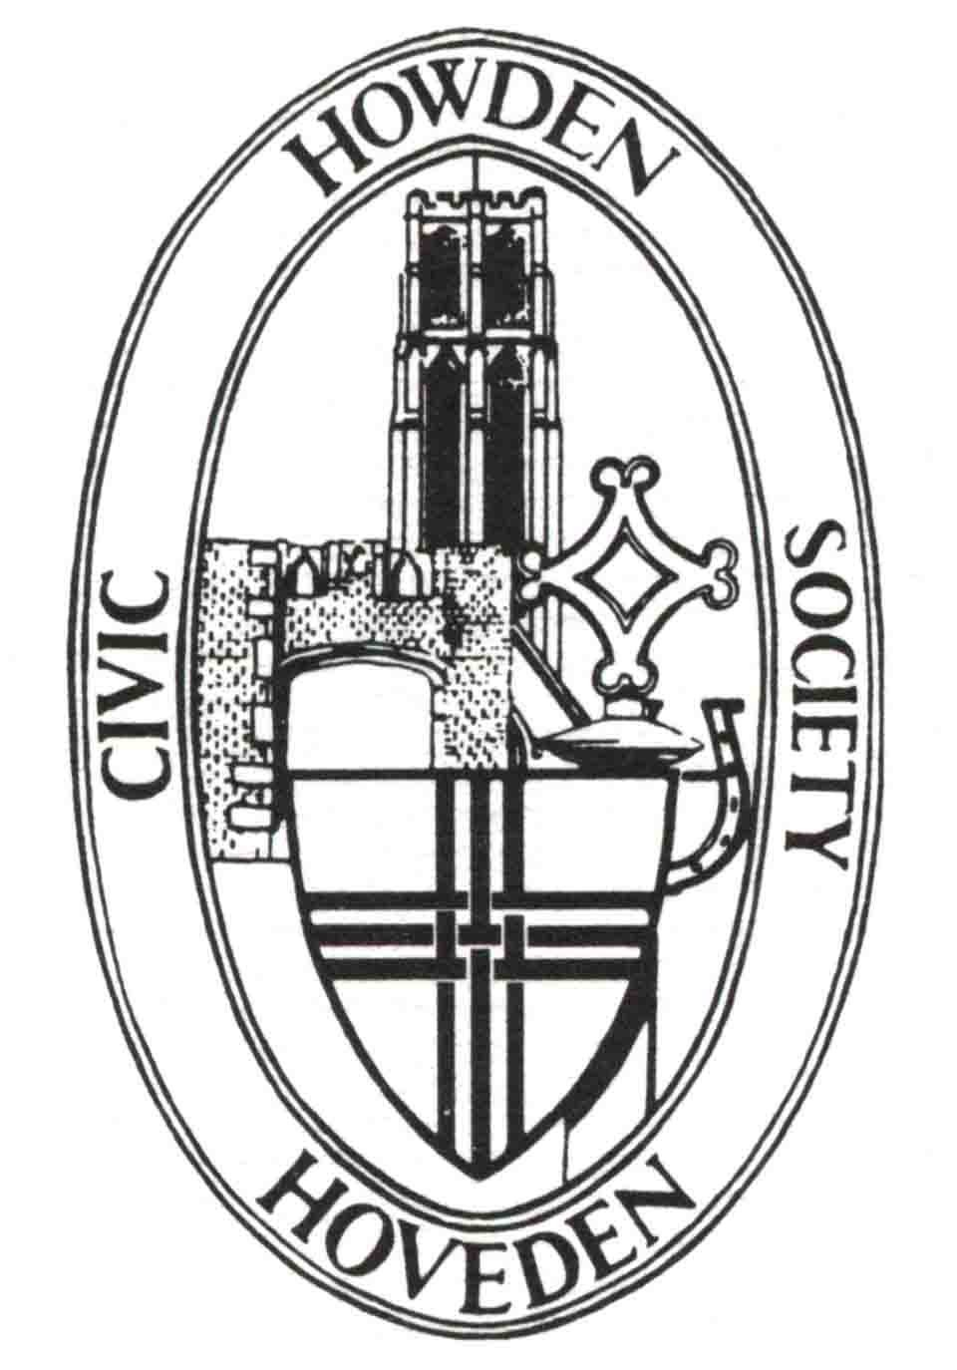
Howden Civic Society

January 2025 Newsletter

1. Letter from the Chairman
Much of this newsletter is about the Local Plan. This may seem to be an academic exercise but it is vitally important for the future of Howden over the next 15 years. But it will also set out what sort of development takes place which will remain with us for 60-100 years. I would like to invite anyone with an interest in town planning or architecture to join with us in examining future plans, especially in relation to the vast area to the North East of Howden. Please contact me if you would like to join us.

Members’ subscriptions are now due. Please pay as soon as you can – you can pay by standing order or BACS to Howden Civic Society, sort code 77-71-61, account number 19478968, by cash at the next social meeting on 5th February in the Masonic Hall or by leaving it in a letter at the Shire Hall addressed to Howden Civic Society. Subscriptions are unchanged at £10 for an individual member or £17 for a joint membership.

2. Dates for your diary
Looking forward to our next meeting at 2 pm on Wednesday February 5th in the Masonic Hall.
Our speaker will be local businesswoman Angela Martinson. Her talk is entitled
GROWING UP IN THE EAST RIDING OF YORKSHIRE
or
'DO YOUR BEST LOVE!'
Angela born and bred in the East Riding, retired Headteacher and now local business owner (Ginger's Ice Cream Parlour in Howden) will use her life experiences to provide a 'memory jerking' social history of the second half of the 20th century.
Audience participation will be welcome as a picture of local life, over the last 70 years in Howdenshire, is built.
Everyone is welcome - £1 for members and £2 for non members with tea and coffee afterwards
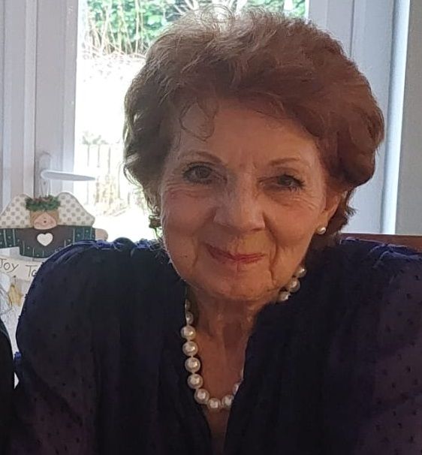

The following meeting on 5th March will include a short AGM. But that will be followed by “Tales from the Butchers Block” by Philip Parkin. If you haven’t heard Philip speaking before, and even if you have, this will be a thoroughly entertaining event.

Both meetings start at 2.00 pm and will be held in the Masonic Hall.

3. Report of recent meeting
We were well entertained by Chris Cade, storyteller and actor, on 8th January. He splendidly played the part of George Hudson, Railway King, describing his ups and downs. We have him (George not Chris) to thank for Howden railway station (although it could have been a little closer to town). The audience, one of the largest we have had in recent years, enjoyed reminding him how old he was at various stages in his life, helped by the fact that he was born in 1800.

4. New on our website
I am earnestly reminding myself how to update the website, so nothing has changed this month.

5. Committee News
There was no Committee meeting in December but we met again on 22nd January. Among the items discussed were:
a) Replacing the headstone of Charles Ledsham’s grave has moved a step further. We have support from the PCC and the Diocesan Advisory Committee in York and are awaiting a decision by the Chancellor of the Consistory Court of the Diocese. Meanwhile we have obtained a grant of £1,000 from the Waterloo Association and are continuing to apply for other grants.
b) We will be taking part in the national promotion of Heritage Open Days in September. Watch this space for our contributions to the theme of “Architecture”.
c) We have suggested to the Town Council several places where changes could be made to the pavements around Howden to improve the ability of people using wheelchairs or scooters to move around comfortably.
d) Our AGM takes place on 5th March in the Masonic Hall. Further details are attached to this newsletter. You are encouraged both to take part in the AGM, usually quite short, and to put yourselves forward to join the Committee. You would be very welcome.
e) We will be involved in a proposed study day with PLACE, a part of York St John University, on Friday 18th July. Details are only just being developed.

6. Howden’s Heritage
Where is it? We are going to include some scenes that may or may not look familiar. This photo shows a nice doorway. Whereabouts in Howden is it?

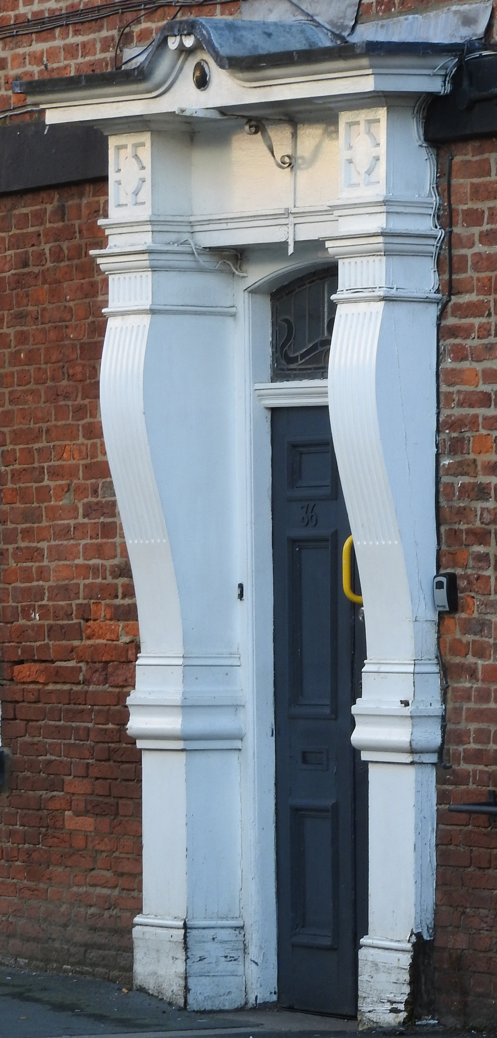

7. Then and Now
The following is an extract from HCS Newsletter of August 2005. This is relevant because there will be an expectation on the developer of the site to the north of Howden to contribute to improvements to the traffic situation in the centre of Howden (see note about the Local Plan below). We may be consulted again!!

“As I write this piece the agents of ERYC are busily painting yellow lines on the roads of our town, indicating that the CPZ is almost upon us. Naturally we hope it will be a success and ease the pain of trying to conduct a normal residential and business life in Howden. Something had to be done, that’s certain, but whether this is the best solution remains to be seen.

As you know, Howden Civic Society has had its doubts from the beginning. We wanted to see any solution to our problems preceded by a serious consideration of the need for more off-street parking and an examination of the merits of a one-way scheme for the flow of traffic through the town. Alright, we were not certain that either proposal was the panacea we were looking for but we thought that the appointment of consultants to advise the Council was the opportunity for an expert review of all possibilities. Sadly this has not proved to be the case.

In the consultation phase we were told that the experts had an open mind and welcomed all
suggestions from the residents of Howden and the representative bodies like ourselves. However, it has become clear that the only suggestions taken on board by the consultants were where the yellow lines were to be painted. Strategic thinking like whether so many cars had to be parked on our streets at all; whether car-parks could be created on the periphery or even in the centre of the town; whether the narrow thoroughfares of Howden would function more safely and effectively in one direction rather than two, was not encouraged and when the Civic Society pressed the consultants we were told that such ideas were not “within their terms of reference”.

In other words it had already been decided just how far ERYC was prepared to go in solving
Howden’s traffic problems and of course how much money they were prepared to spend. Some would no doubt call that a prudent course of action; others will feel cheated and frustrated that so much discussion was allowed to happen and so much time and energy were expended when nobody was intending to take the outcomes seriously.”

Let’s see what happens this time because the volume of traffic passing through and around Howden is already increasing.

8. Planning Matters
The Planning Inspector (Katie Child) has published her final report on the Local Plan Update. This has been produced as a report to ERYC Cabinet for discussion on 25th February 2025, although the time for consultation is over. The Plan, as produced by ERYC, had a number of deficiencies in respect of soundness and legal compliance but, if the minor and main modifications suggested by Katie Child are agreed, the plan Update is capable of adoption.

The Local Plan Update comprises 289 pages and covers the whole of the East Riding but I have only looked at the bits relating to Howden. If you want to look at the whole document it is available via the ERYC Forward Planning website.

The Local Plan Update (the previous one was published in 2016) incorporates two main documents – the Strategy Document, which sets out the overall direction of the Local Plan – and the Allocations Document, which allocates sites for new development and different land uses (such as housing, retail, industry or open space). These documents are supported by a Policies Map, Supplementary Planning Documents and a Design Code. Also a Town (Howden is identified as a Town) can prepare a Neighbourhood Development Plan to set out a shared vision and planning policies for their area. I understand Howden will not be preparing such a plan.

The Update includes a Place Statement for Howden and how it would look in 2039. It makes interesting reading and, if adopted, can be included in a future newsletter so you can judge for yourselves.

The Allocations Document identifies three main areas for housing development and I have picked a few points out that may be of interest.

HOW-A the area north of Shelford Avenue is almost complete. But it states that “Proposals will be required to provide a road link between Selby Road and Station Road, with cycle and pedestrian facilities”. So this has not been abandoned after all.

HOW-E land south west of Boothgate. This site is considered suitable for 112 houses as it has been extended to compensate for the loss of a site off Thorpe Road which has been acquired for employment.

HOW-G land North East of Howden. This is the vast extension of the town from the school playing fields up to the station. You may know that outline planning permission has already been granted for mixed use including housing, employment, retail, community and open space uses. A relief road should be provided through the site to connect Station Road to Thorpe Road to divert HGVs from Flatgate and Hull Road. The overall capacity of this site is around 1,865 houses although not all of these are likely to be built before the end of the plan period (2039). This will almost double the population of Howden!
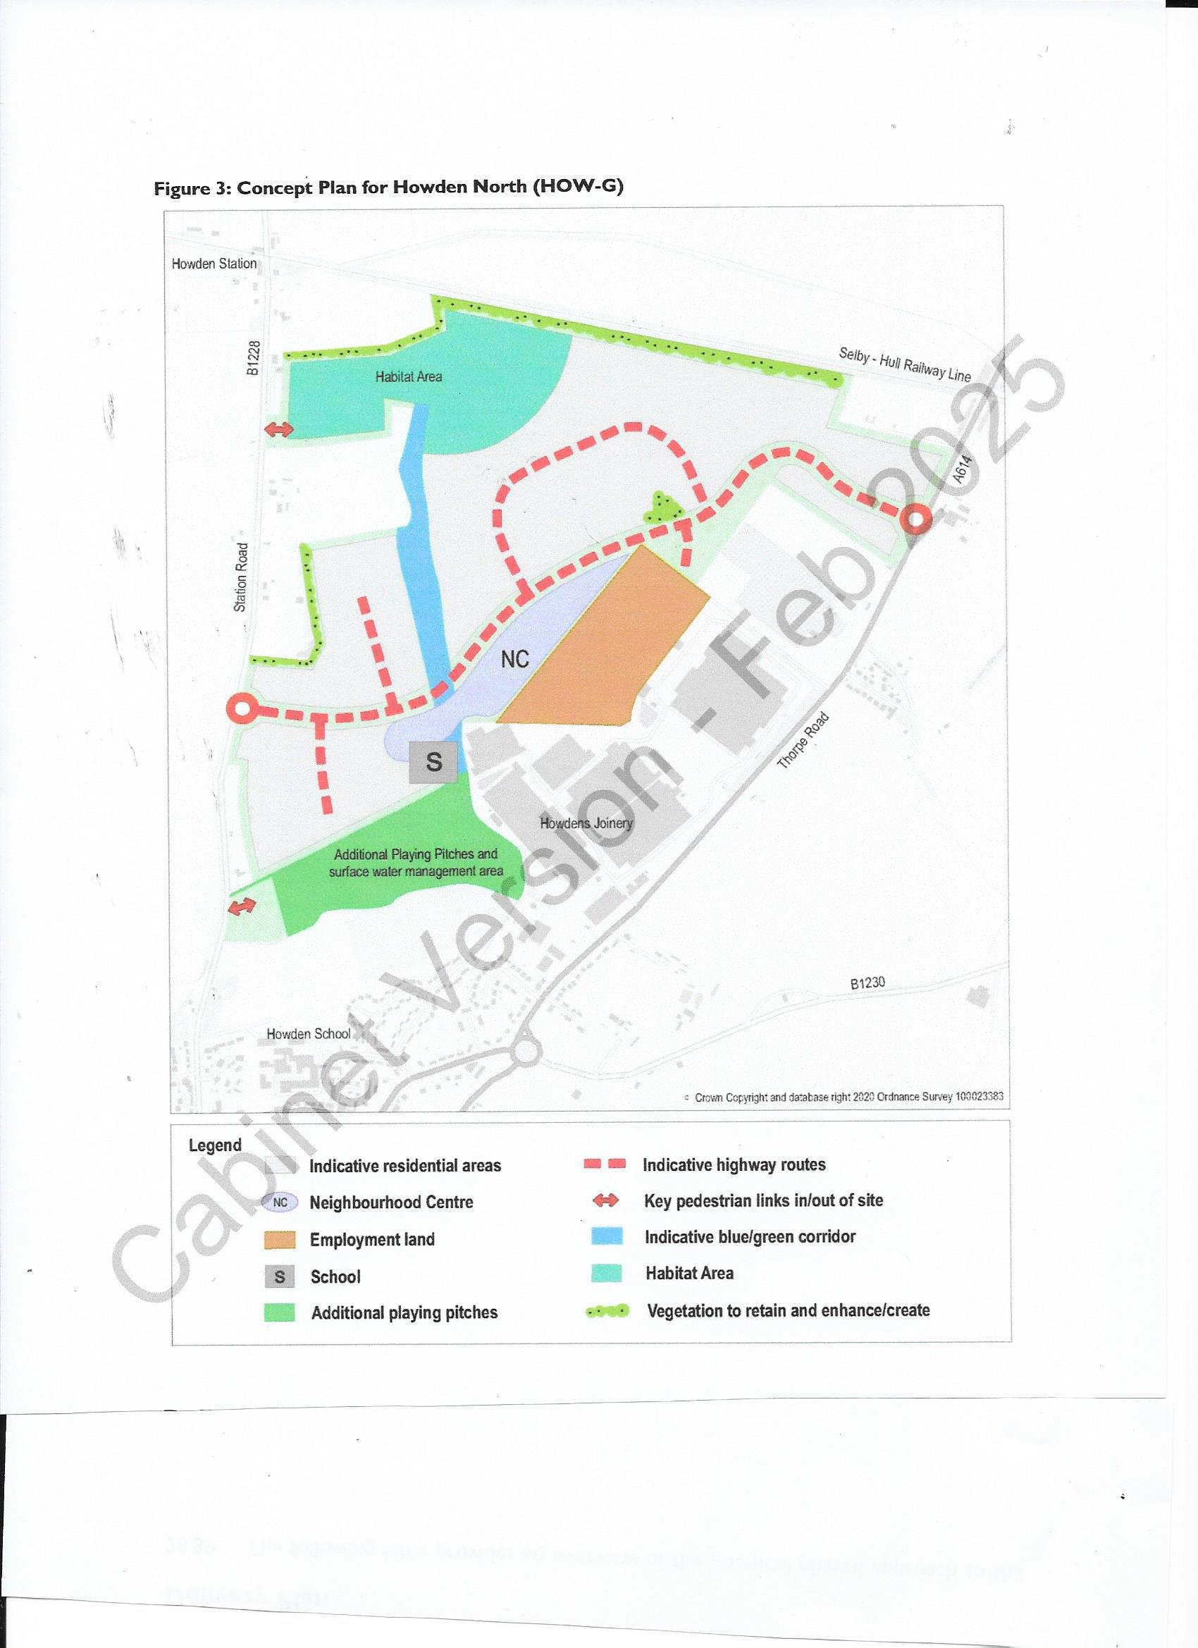

A proposal is identified to “Deliver off-site highway interventions to manage traffic around the town centre and provide relevant highway improvements around the town to accommodate the level of development proposed”. No details of what improvements or when.

The site will need to be “developed in accordance with a masterplan (incorporating a design code) to be prepared, submitted and approved in writing by the local planning authority” so we shouldn’t get a repeat of the monotonous street scene in the recent development off Selby Road.

The developers, whoever they may be, will also need to take account of the historic built environment and heritage assets within and around Howden.

The town’s existing foul water system will need to be carefully considered when developing plans for the site. “A scheme which by-passes the existing network within the centre of Howden is likely to be the only appropriate option”.

The plan includes a concept plan (the above map) showing a possible layout. This still includes the proposal to site the new primary school to the south of the relief road so young children from the vast majority of the site will still have to cross the road which carries all the HGVs and other traffic. Does this make sense?

HOW-H Expansion Land North of Ozone Business Park. This is the only area of industrial development envisaged within Howden and will be separated from the housing development in Boothgate.

Further information is included in the plan. We will see what happens on 25th February and report back in the February newsletter.

9. Howdenshire News
I thought you might like to see the winner of the Winter Windows competition in Howden during December. Here is the winner “Lusso”, in second place was Howden Skin Clinic and third was Touchwood Homecare DIY. As reported on the Visit Howden website, “the town’s traders have gone to great efforts to add some festive sparkle to the town… and a big thanks to Linda and Marian who braved [that]weekend’s weather to judge this year’s competition”.

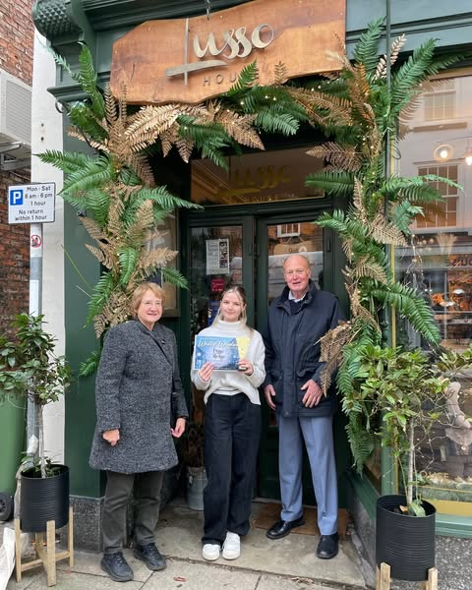

10. For Sale
Our recent publications are for sale in both Chappelows and Touchwood. We are greatly indebted to both community minded businesses for helping to bring our publications to the knowledge of residents and visitors alike.

Philip Mepham
Chairman
Howden Civic Society
30th January 2025

2025 AGM AND ELECTIONS TO COMMITTEE

Our AGM will be on Wednesday 5th March 2025 at 2.00 pm. In line with our constitution, all Committee members and Officers (Chairman, Vice Chairman, Honorary Treasurer and Honorary Secretary) will be up for election. Nominations need to be made at least 14 days before the AGM and need to have the consent of any proposed nominee. We would welcome your involvement in whichever way you prefer, whether or not as a member of the Committee. If you need more information about the roles of Committee members please contact me.

The Agenda for the 46th AGM is as follows:

List of members present

Apologies

Minutes of 45th Annual General Meeting

Chairman’s Report

Treasurer’s Report

Trustee’s Report

Elections for 2025/2026
- Chairman
- Vice Chairman
- Secretary
- Treasurer
- Committee members
There are vacancies for up to 15 Committee members

Attached is the Chairman’s Report

HOWDEN CIVIC SOCIETY
CHAIRMAN’S REPORT TO ANNUAL GENERAL MEETING 5th MARCH 2025
Summary
This year has been an active one for Howden Civic Society in many ways, some of which may not have been visible to members, so Newsletters were changed to make them more informative.

Social Meetings
Rhythm and Rhyme with time for a song – Mike Smith
Inns of Howden – Susan Butler (at very short notice)
Domestic Service – Steve Clarke
Goole, an Inland Port – Unique? - Graham Buckton
History, Development and Future Plans of Howden Joinery Group plc – Julian Lee and Colleagues
Local History – Susan Butler
Yorkshire’s Seaside Heritage – Mike Higginbottom
History of Airmyn and Boothferry – David Galloway

This year we again had to change our meeting venue in April and November but were fortunate again to be hosted by the Methodist Church in Hailgate. Our planned visit to Ellerton Priory in June had to be postponed due to the church being isolated by Yorkshire Water’s construction of a new sewerage system through the village. This visit has been rearranged for 4th June 2025 when it will coincide with the 30th anniversary of the Trust that rejuvenated the Priory, and when we have been promised even better cakes. A Christmas event was held for the first time in recent years and proved to be an entertaining afternoon for those attending. A photo quiz was presented by Geoff Taylor which puzzled many as they showed views of a range of Howden scenes and these will feature in future newsletters. Susan Butler also contributed quizzes and prompted much discussion. This format will be repeated in 2025 on 10th December (but not 3rd as quoted in the programme).

Exhibitions
Howden Civic Society was represented at the 2024 Howden Show in the indoor Trade Tent. This proved to be an excellent position and deemed a success in terms of the number of people who viewed our displays and in the number of publications sold.

Our exhibition, held in Howden Minster between 9th and 14th September, as part of the national Heritage Open Days initiative, had the theme of Communication. A total of 289 people visited the exhibition. Comments by visitors reflected the first aim of the Society which is “to stimulate public interest in [Howden]”. Many visitors said they had never been to Howden before and some that they didn’t previously know Howden existed. Some Howden residents mentioned that they had learnt a great deal about Howden of which they weren’t previously aware. So I think overall the exhibition was a success. Susan Butler and Marian Thomas led guided walks around Howden. Several people booked who had seen the walks advertised in a publication produced by Beverley Civic Society. A total of 20 people took part and benefited from the extensive local knowledge of the leaders.

Awards
No awards were made in 2024. Recent additions are in our revised Howden Heritage booklet.

Publications
No new publications were produced in 2024. We are, however, greatly indebted to Chappelows and Touchwood for making our publications available for sale. This has made a marked improvement in the availability of publications for which we are very grateful.

Publicity
Susan Butler has done a wonderful job on our behalf in creating and populating our Facebook pages. I think this has been one of the main reason why our social meetings attract large numbers of visitors who often outnumber our members at social meetings. Marian, Trudy and Geoff collaborate in producing, laminating and installing posters to advertise social meetings and exhibitions and I have a regular item in Mike Smith’s “Briefly”.

The display case in the Shire Hall has had to be removed as building work continues but will be reinstalled when the work is completed. Updating and improving our website is still “in progress”.

We are discarding the white wooden display stands as they are difficult to transport and some had woodworm. These are being replaced by new lighter and more manageable boards using funds granted to us by Howden Town Council.

Planning
This year has been particularly busy in relation to responding to consultation documents produced by East Riding of Yorkshire Forward Planners (ERYC). The major extension of Howden between Thorpe Road, Station Road and the railway is moving forward. Several parts of the proposal have already been granted permission and it is expected that about 1,865 new homes will eventually be built, although not all before the end of the Local Plan period in 2039. Work on the relief road should start in January 2025.

One of the consequences of the new Government in July 2024 was a consultation on a new National Planning Policy Framework. One main proposal was new higher mandatory housing targets set for each Council, and also improved community engagement. These and many other proposals were the subject of consultation and we await final decisions following the consultation.

Another consequence of the new Government was further consultation on the Local Plan Update. This has now been completed and the Planning Inspector’s report published in December 2024. This will be considered by ERYC Cabinet in February 2025.

The ERYC produced a draft Design Code for consultation. This will clarify design expectations and improve the quality of new development. This will be incorporated into the proposed Masterplan for the new site north of Howden and hopefully will result in a more attractive development than that imposed on the town north of Shelford Avenue and Selby Road, which is far from the “beautiful” development envisaged by the Design Code.

Development
We are participating in a Signage Group with Howden Town Council to improve the image and publicity about Howden. The Winter Windows competition resulted form our first meeting and was won by Lusso in the Market Place. Many thanks to Linda (Lin) Lavender and Marian Thomas for judging entries and congratulations are due to all Howden traders for their participation.

Thanks to the Committee
We continue to be blessed by an active and thoughtful Committee and I am very grateful for their continued involvement. This year we welcomed Linda Lavender to become Secretary, replacing Sue Tite who sadly passed away during the year. We are still in need of more Committee members and there is scope for involvement in many ways.

Philip Mepham,
Chairman,
Howden Civic Society
28th January 2025.

