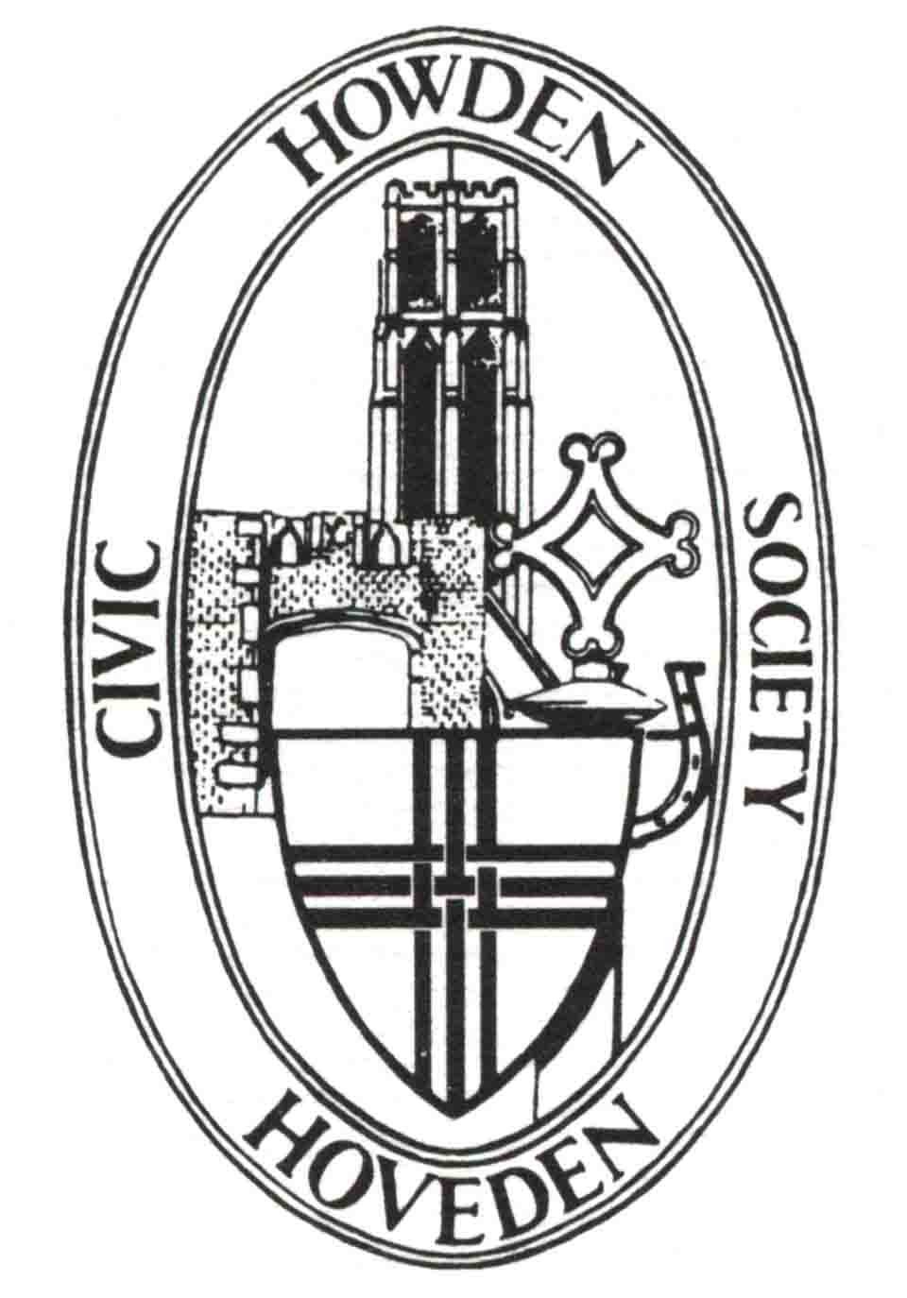
Howden Civic Society

April Newsletter

Letter from the Chairman
Firstly we would like to record our thanks for the enthusiasm and life of Ken Deacon. His funeral, in case you didn’t know, is on 28th April at 11.00 in Howden Minster.
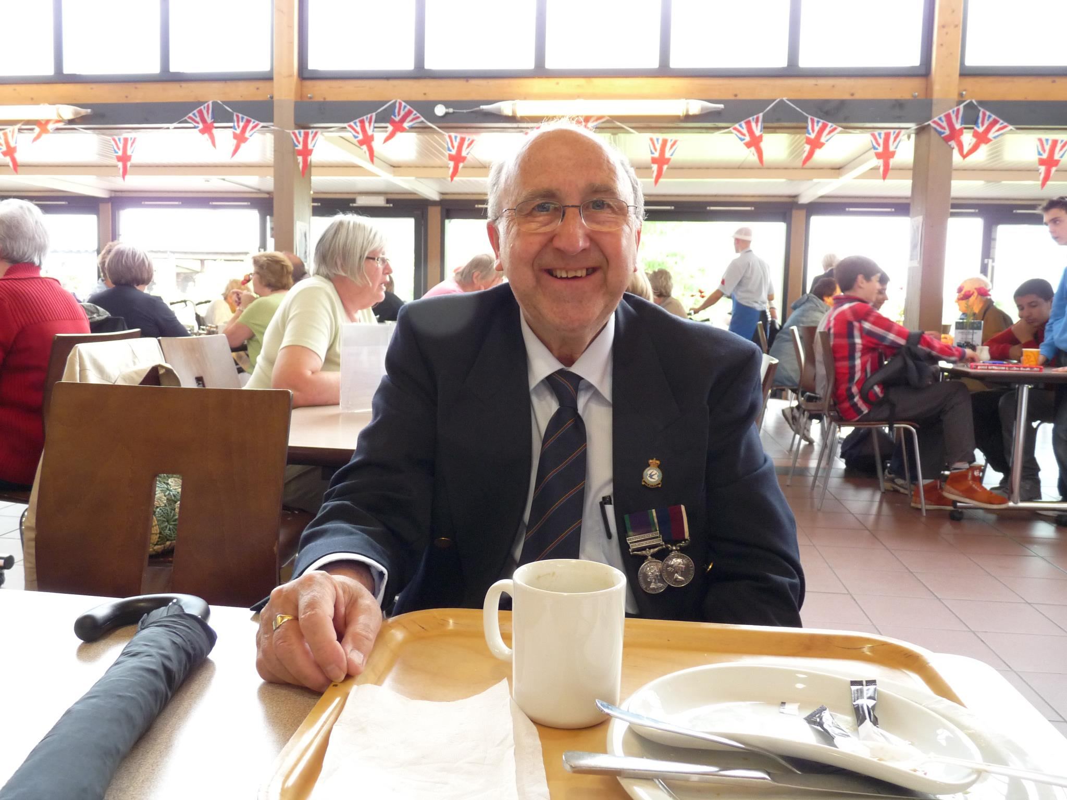

This is how I remember him.
We are currently working to raise funds to replace the headstone of Charles Ledsham in Howden Minster churchyard. He was one of the very few survivors of the Battle of Waterloo who can be identified by his grave but who was not an officer. You can help us raise the necessary funds without actually costing you anything. This is by supporting us for free on #easyfundraising. Your ongoing support means the world to us! If you've not signed up yet, please join today and you can raise free donations for Howden Civic Society every time you shop online this year! Over 8,000 retailers like eBay, Argos, Marks and Spencer, John Lewis & Partners, Etsy, Tesco and Just Eat will donate at no extra cost to you. Log into www.easyfundraising.co.uk and select Howden Civic Society as your favoured cause to support.
Easyfundraising partners with over 8,000 brands who will donate part of what you spend to a cause of your choice. It won't cost you any extra. The cost is covered by the brand.

Dates for your diary
On Wednesday 7th May at 7.30 pm we will be showing a presentation by Henry Farrar about “Rides through Yorkshire with Daniel Defoe”. Between 1724 and 1727 he travelled and then published his book “Tour through the whole island of Great Britain”. The third volume included Letters 8 and 9 with the latter describing his visit to Snaith, Selby and Howden. This tour was innovative partly because Defoe actually visited the places he described. Come to the Masonic Hall on 7th May and hear and see Henry’s presentation about Defoe’s travels through Yorkshire.
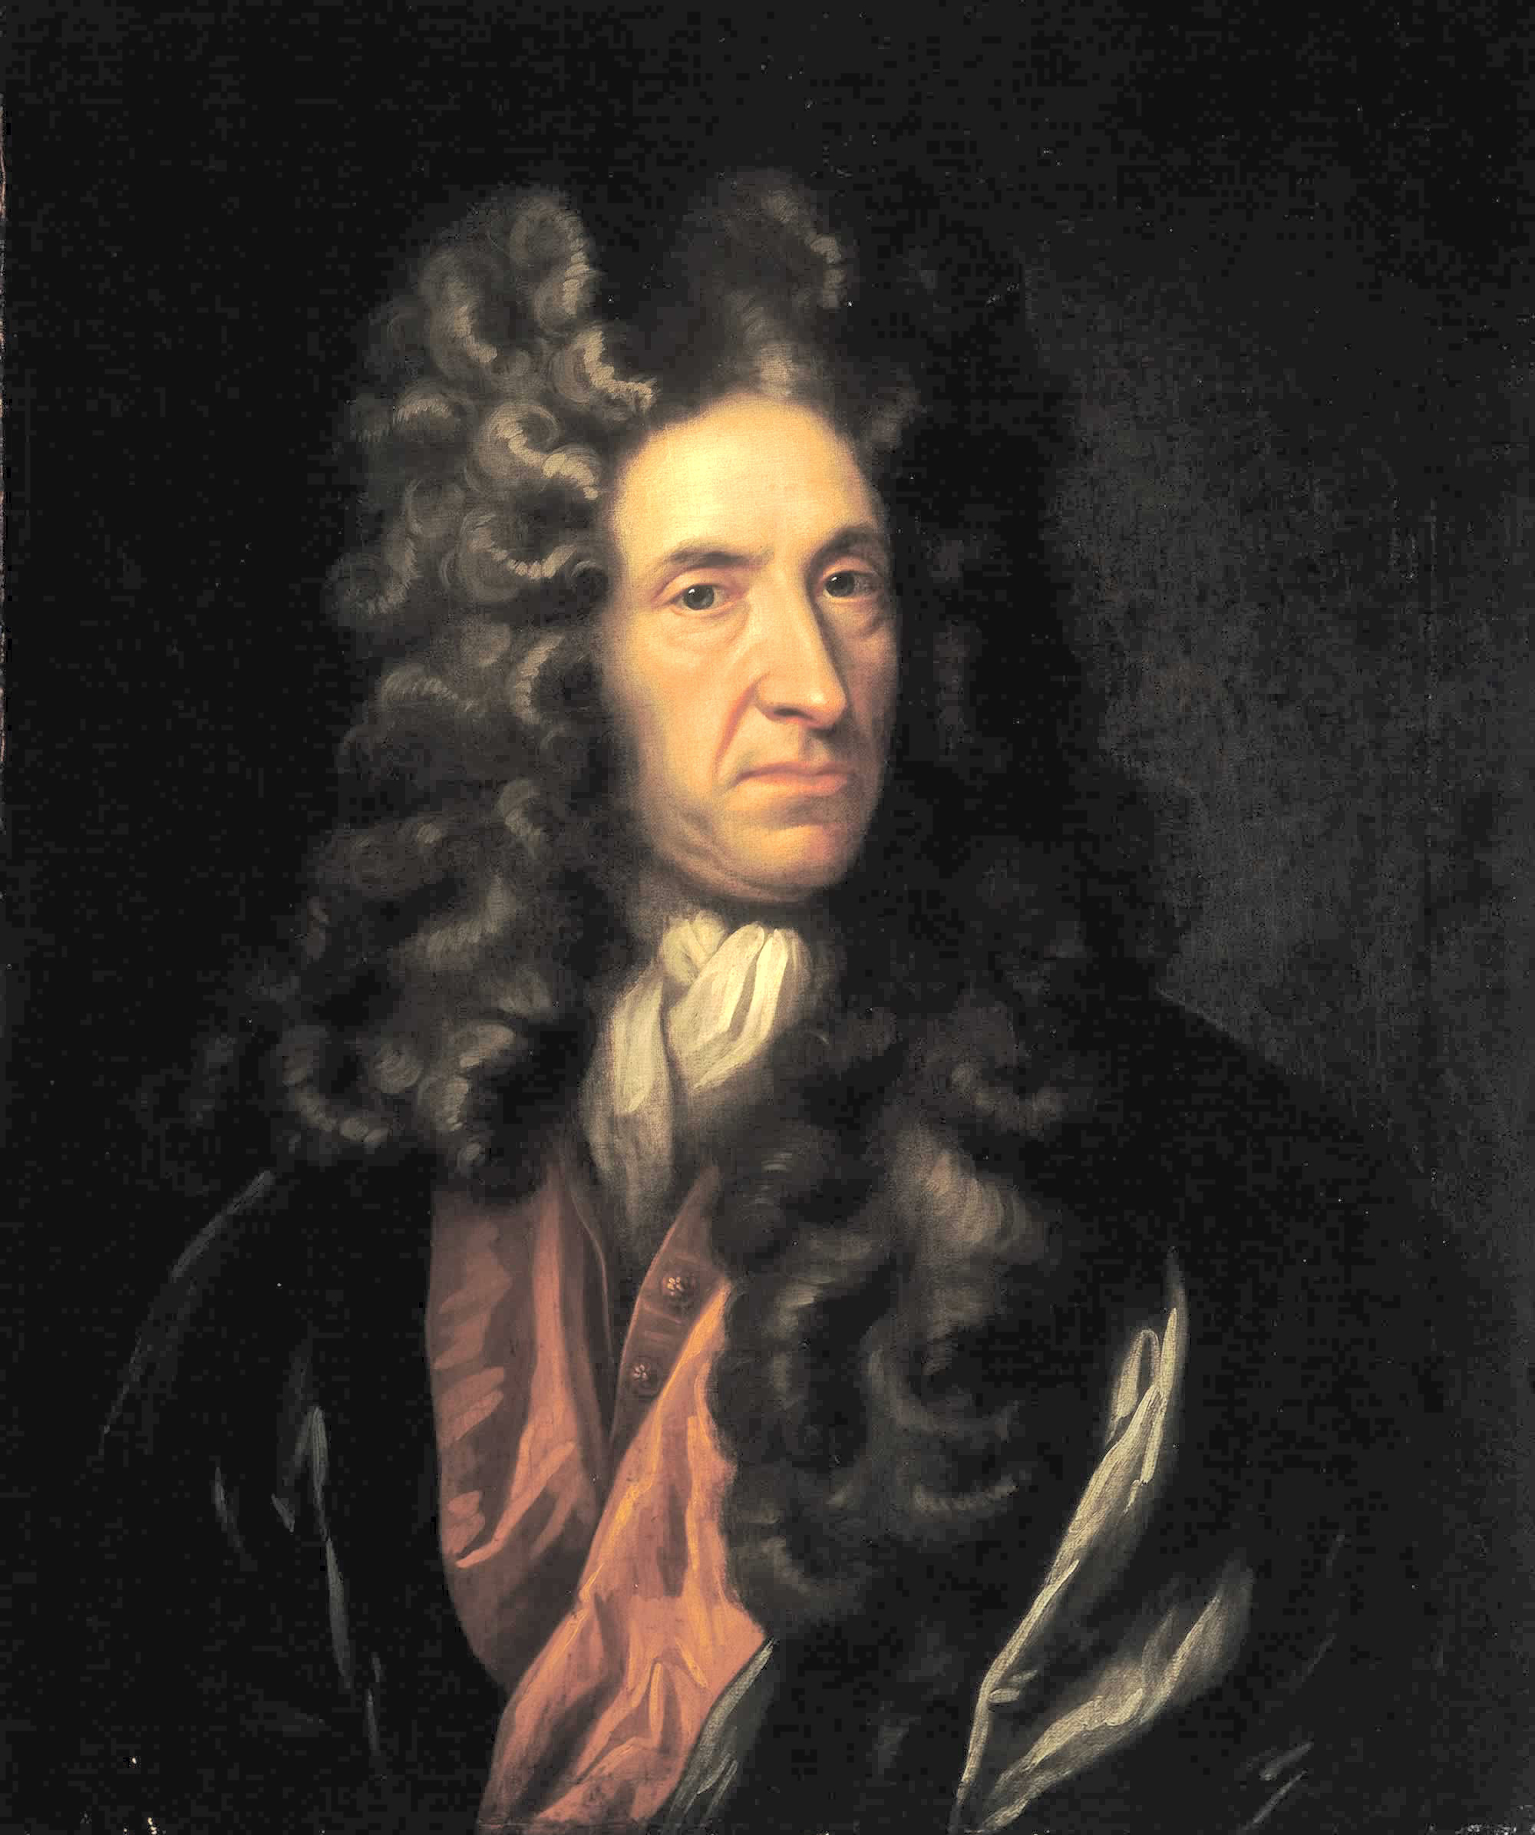

Portrait of Daniel Defoe, National Maritime Museum, London
Unknown, style of Sir Godfrey Kneller
On 3rd May we will be present on Vintage Day with a stall in Howden Minster where we will be showing a slide show illustrating Howden in the 1970s and you will also be able to purchase our publications. We might even be able to display a few vintage items from our collection.
We will also be present in Howden Show on 6th July where the theme of our display will be the R100.
And finally plans are already underway to hold an exhibition in the Shire Hall on 20th September and you will get another chance to see the original Howden Mural and much more.

Report of recent meeting
Our recent social meeting on 2nd April turned out to be a fascinating insight into one of our prominent, but perhaps under-recognised, local success stories. Martin Ellis of Plant Raisers Ltd gave an illustrated presentation about the history, current activities and some future plans about their business. You will, if you have a garden, almost certainly have bought vegetable plants which were originally raised by his company but bought through garden centres and supermarkets. We were very grateful for his presentation which was very much appreciated by the many people, members and non-members alike, who were there.

Committee News
Our meeting on 9th April included the following progress:
Susan has received an invitation to attend a meeting of Howden Rotary to discuss Charles Ledsham.
The slides inherited from the Camera Club have been reviewed and a selection converted into a slide show to display on Vintage Day in the Minster.
The list of suggestions about improving access around Howden for scooters and wheelchairs has been sent to ERYC Highways for attention.
Howden Civic Society membership now totals 50, the highest for some time.
We have decided to change the admission charges at social meetings. From September’s meeting onwards we will ask £3 for non-members while there will be no charge for members.
We are making progress with the speakers for 2026 and hope to have a list ready by the time of Howden Show.
The rejuvenation of the Minster View has now received full permission from ERYC.
The proposed changes in signage at Bowman’s Commercial Hotel have been supported.
Committee members will be judging the Vintage Day window displays.

Howden’s Heritage
In view of the scrapping of Howdenshire and Howden as a named parliamentary constituency, I thought it relevant to commemorate its passing by recalling some of its history.
Howdenshire lies between the north bank of the River Ouse, the east bank of the River Derwent and the south bank of the River Foulness. In the north, the line is along other watercourses: the channel of the Old Derwent and the drains called Common End Dyke and Langdyke.
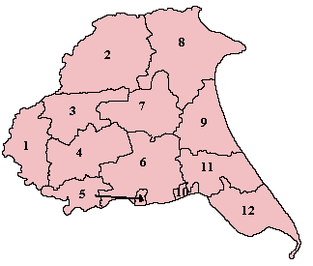

Howdenshire is No. 5 on this map of East Yorkshire
Howdenshire was a county constituency in Yorkshire which returned one Member of Parliament (MP) to the House of Commons of the Parliament of the United Kingdom, elected by the first past the post voting system.
It was created for the 1885 general election, and abolished for the 1950 general election.
The boundaries varied and included as follows:
1885–1918: The Sessional Divisions of Holme Beacon, Howdenshire, South Hunsley Beacon, Wilton Beacon, and Ouse and Derwent (except the part included in the extended Municipal Borough of York).
1918–1950: The Urban Districts of Hessle and Pocklington, the Rural Districts of Escrick, Howden, Pocklington, and Riccall, in the Rural District of Beverley the civil parishes of Brantingham, Ellerker, Elloughton with Brough, and South Cave, and part of the Rural District of Sculcoates.
Howden as a constituency was created for the 1955 general election, made up largely of the constituency of Beverley (losing some territory in the south to Haltemprice, and taking some in the east from Bridlington).
Between 1976 and 1983 the Boundary Commission undertook the most sweeping review since the introduction of universal suffrage. 90% of the UK’s seats were new or revised. This was the third review undertaken since the process was introduced in 1950. Howden then became part of Boothferry Constituency for the 1983 general election but that was abolished in 1997.
As Humberside was awarded an extra seat in the boundary review implemented in 1997, the constituency was split into four, Brigg and Goole, East Yorkshire, Haltemprice and Howden and Beverley and Holderness being the destinations of the constituents in descending order. This area was part of Howden and Haltemprice Constituency from 1997 to 2024. The constituency was named after the region of Haltemprice and covered a large, wide area stretching from the border of Hull in the east to Howden in the west and northwards to Holme-on-Spalding-Moor towards York in the Yorkshire Wolds.
The Boundary Commission undertook another review of all boundaries in England in 2023 and the names of Howden and Howdenshire disappeared to be replaced after becoming part of ‘Goole and Pocklington Constituency’.
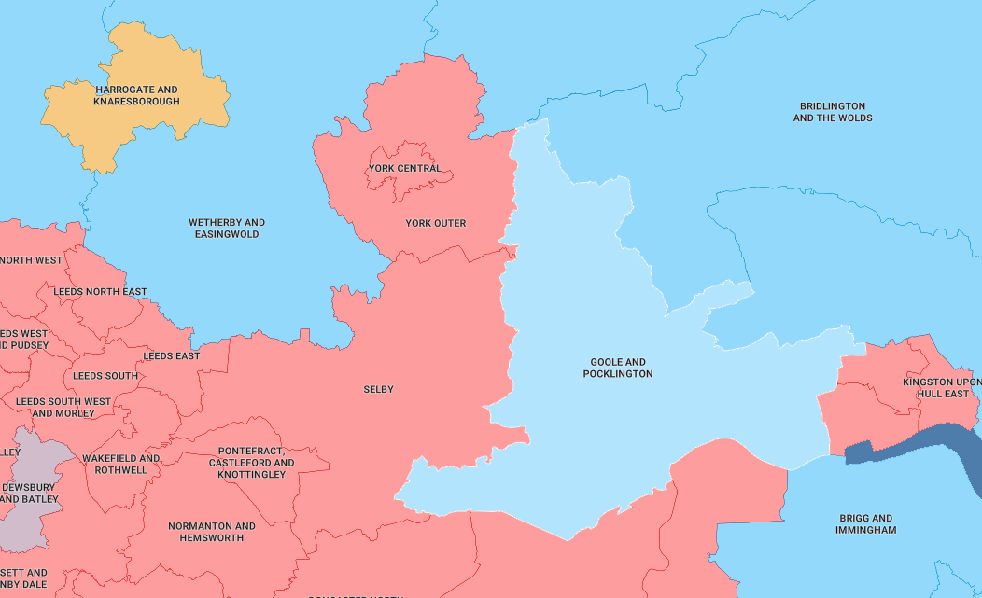

Correct at October 2024
I hope that clarifies which area of East Yorkshire we represent!

Then and Now
HOWDEN: THE UNTOLD STORY by Ken Powls (from Howden Civic Society Newsletter August 2006)
Ken Powls book is a slim volume of some 46 pages but it packed full with facts about the
history of Howden which have not previously been published. In his Preface Mr Powls explains that there are three main sources of information which he has tapped: material omitted from the book on Howden which he co-authored with Susan Butler; material passed down by his great great grandmother and by his grand father; and not least his own memories. These latter two sources are perhaps most likely to capture the imaginations of his readers.
In a section entitled simply The Church, Ken Powls reveals that his great great grandmother had been the sextoness from 1783 and his grandfather from about 1860. Both had recorded a fascinating collection of data in their burial books which had lain undisturbed in his father’s shop until recently. These show for instance that before the Great Horse Fairs of the time, the church tower was cleaned externally by men suspended in baskets and that in 1851 a Mr Sinclair, a local builder, scraped and yellow-washed the church interior walls, a job which took him three weeks to complete. In 1868 we are told tantalisingly that the headmaster of the Grammar School, the Rev S Screeton, was dismissed for “extraordinary doctrines”. The Grammar School was of course lodged
within the Minster buildings and closed only when the then headmaster died in 1925. Mr Powls was himself a pupil at the school when it closed and in order to continue his education he then had to face four years of travelling across the river by ferry to Goole in what he writes was “sometimes a terrifying journey”.
We are extraordinarily lucky that Ken Powls, at the age of 93, has the energy and the
determination to prepare a book like this, and that his memory is so clear that he re-creates for
us a world which seems to have gone forever. “Up to the early 1930s, the fire engine was kept in my father’s garage in St John’s Street, with a tower for drying the hoses behind the garage. The alarm was raised by a maroon set off in the Police Station, and which exploded over the town with a mighty bang.” There are some good photographs including one of his father’s open charabanc in which he would transport the folk of Howden on a day trip to Bridlington for five shillings.
This book is strongly recommended, at a cost of £3, it is available for purchase alongside our
other Society Merchandise and also at Chappelows Newsagents in the Marketplace.

Planning Matters
The East Riding Local Plan 2020-2039 and the East Riding Design Code SPD were both adopted by the East Riding of Yorkshire Council on 2nd April 2025. The Local Plan now forms the basis for determining planning applications in this area. The Design Code is a set of simple design requirements that provide a specific guide for the development of a site or area, bringing together important planning considerations such as nature, heritage, movement and health and wellbeing.
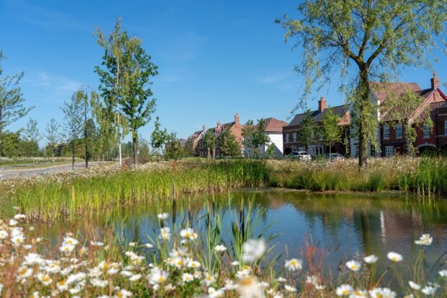

The East Riding Design Code has been prepared to clearly set out design expectations and improve the quality of new development across the whole of the East Riding of Yorkshire. The East Riding Design Code is a Supplementary Planning Document (SPD) supporting policies in the East Riding Local Plan. This means it is a material consideration in the determination of planning applications. It is relevant to all new developments, for all uses, including extensions to existing buildings. The design code seeks to ensure that all development is responsive to its context, sits comfortably in the landscape and encourages biodiverse and sustainable choices.
A household development version of the design code has been created to make it easier to see the codes and key guidance which are for extensions to existing houses. All the chapter numbers and code numbers in this version of the document are the same as in the full code but they are all in one place for ease of use. The document is entitled ERYC Design Code (Householder Development Only).pdf and at 18 pages it is much more user friendly than the main Design Code which comprises 86 pages.
The reason I have been repeatedly bringing these two document to your attention is because they, together, will prescribe what future development takes place and how it affects the town of Howden. Howden Civic Society will be scrutinising future developments, especially the 1800+ house development north of the town. This Design Code, had it been in place 10 years ago, would have resulted in a much more acceptable development between Selby Road and Station Road, so we don’t want that situation repeated in the future. Design Co Dl
In conclusion
Our contact details are as usual:

email: info@howdencivicsociety.co.uk

mail to: Howden Civic Society
c/o The Shire Hall
Market Place
Howden
East Riding of Yorkshire
DN14 7BJ

Philip Mepham,
Chairman, Howden Civic Society
20th April 2025

